Sprint -03

|  |  |
| --- | --- |
| Date | 18 November 2022 |
| Team ID | PNT2022TMID26870 |
| Project Name | Project – Smart Farmer - IoT Enabled Smart Farming Application |

MOBILE APP USING MIT APP INVENTER :

view :

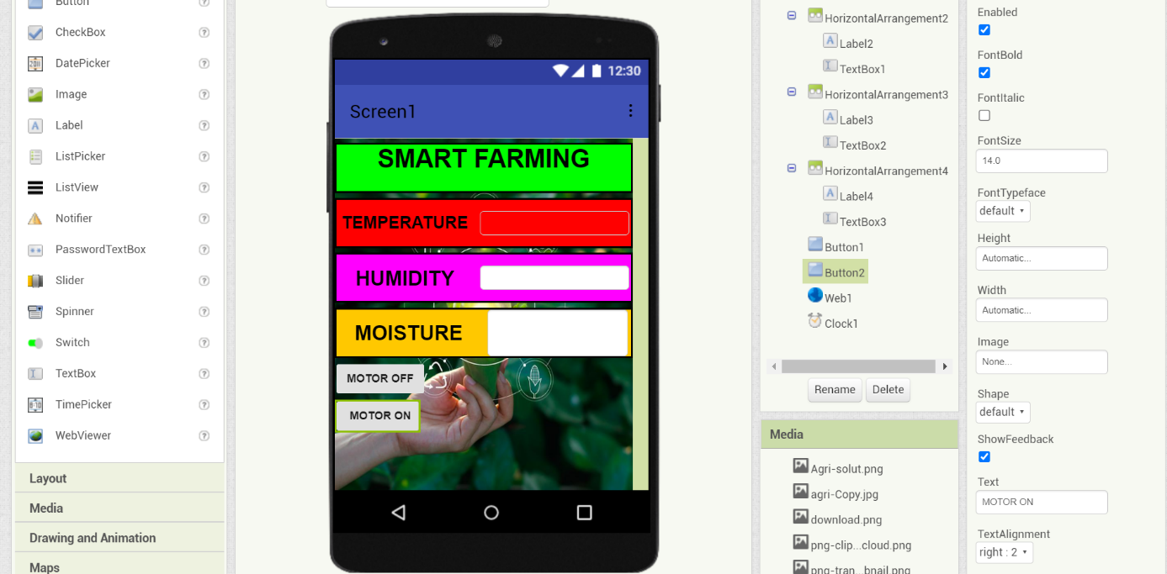

BLOCKS : 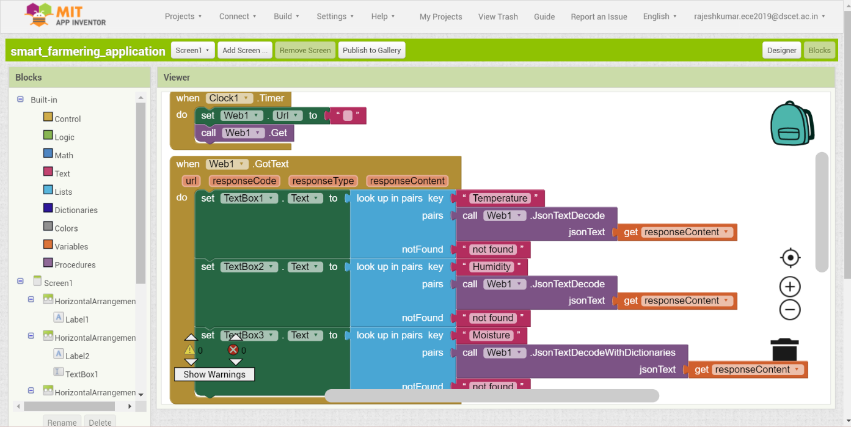

Qr code:- 